Course _______Specialist______ Year __12_____

Student name: ________________ Teacher name: ________________

Date: 17 June Weds p3 (Advo)

Task type: Response

Time allowed for this task: _____45______ mins

Number of questions: _____7______

Materials required: Calculator with CAS capability (to be provided by the student)

Standard items: Pens (blue/black preferred), pencils (including coloured), sharpener, correction fluid/tape, eraser, ruler, highlighters

Special items: Drawing instruments, templates, notes on one unfolded sheet of
A4 paper, and up to three calculators approved for use in the WACE examinations

Marks available: __42____ marks

Task weighting: _12___%

Formula sheet provided: Yes

Note: All part questions worth more than 2 marks require working to obtain full marks.

Q1 (3.3.5- 3.3.6) (2 & 3 = 5 marks)
Consider a car A that has an initial position vector km and moving with a constant velocity of km/h.
- Determine the position vector in 5 hours from now.

Consider a second car B that has an initial position km and a constant velocity of km/h.

- Determine if the two cars collide and if they do the position vector of this point of collision and the time it occurs.

Q2 ( 3.3.1, 3.3.3) (3 & 2 = 5 marks)
Consider the two lines
- Determine the point of intersection, if any.

- Determine to the nearest degree the acute angle between the two lines.
(Consider the plane that contains both lines)

Q3 (3.3.8) (2, 3 & 3 = 8 marks)
Consider a plane that contains the point and has a normal vector .
- Determine the vector equation of the plane.

- Determine the point of intersection of the line with the plane above.

- Determine the distance of point from the plane above.

Q4 ( 3.3.9-3.3.10) (3 & 3 = 6 marks)
- Solve the following system of linear equations. Working must be shown.

Consider the constants in the system below.
- Determine all the value(s) of such that:
- There will be an unique solution
- There will be infinite solutions
- There will be no solutions
`

Q4 cont-

Q5 (3.3.11 – 3.3.15) (3 & 3 = 6 marks)
Consider an object moving with acceleration at time seconds. The initial velocity is and initial displacement .
- Determine the position vector at time seconds.

- Determine the distance travelled in the first 10 seconds. (One decimal place)

Q6 (3.3.15) (3 & 2 = 5 marks)

Consider an aircraft with position vector at time hours. At the top of a building stands an antenna with the position vector of the highest point being .
- Determine the times the aircraft is less than 100 km from the top of the antenna.

- Determine the closest approach of the aircraft and the time it occurs.

Q7 (3.3.15) (4 & 3 = 7 marks)

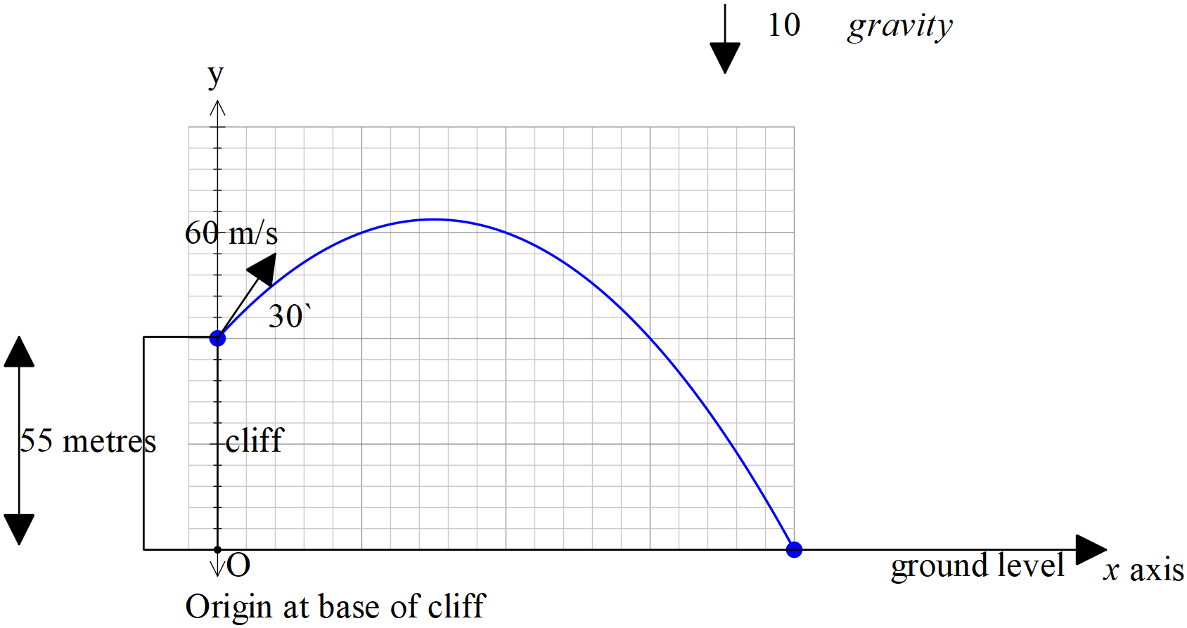

Consider a football that is kicked off the top of a cliff of height 55 metres with an initial speed of 60 m/s at an angle of with the horizontal. The acceleration due to gravity is .
- Show using vector integration how to determine the exact cartesian equation of the path using the base of the cliff as the origin.

- Determine the time, one decimal place, taken to hit the ground and the horizontal distance of this point from the base of the cliff.

End of test

